Let me introduce, with a fanfare, the Kitchen Radar 3000 According to the advertisement, this kitchen appliance brings “state-of-the-art military-grade components into your kitchen so you will never ruin any recipe and will become the fastest cook in town.” Whoa, totally thrilling, isn’t it? Well, not really.

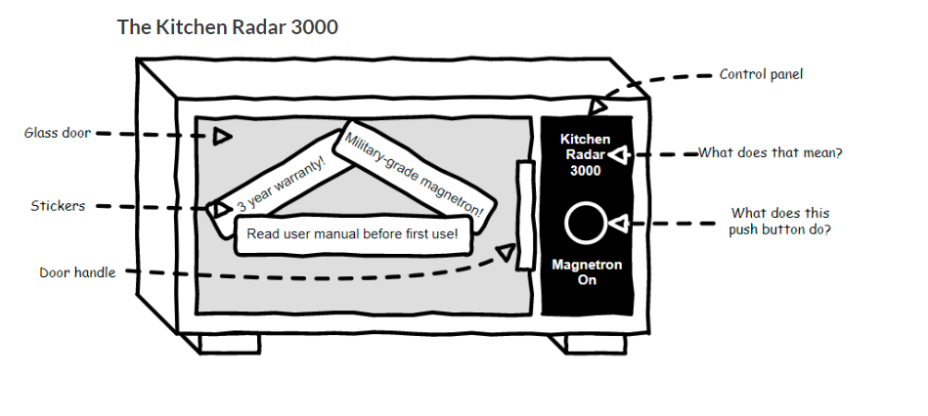

**Users Mind**

What on earth is a Kitchen Radar 3000?

What is a magnetron?

What happens when it’s turned on?

But look, there’s a sticker on the glass door that invites us to read the user manual

